Software Developer C++

TeleTrader d.o.o. is part of TeleTrader Software Group, a software company specialized in stock market data and financial analysis, offering a broad portfolio of tools for the processing, visualization and analysis of stock market data. TeleTrader as an internationally acting company head-quartered in Vienna, Austria is selling its products in Europe, North America and Asia and is developing its software in Belgrade.

Within its Market Data Server department TeleTrader is offering the following vacancy:

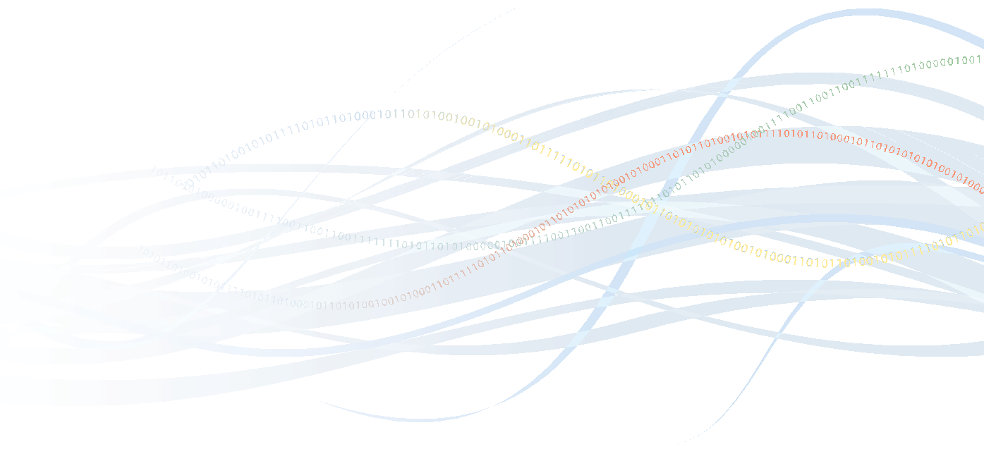
Main Tasks:
- Developing new server side components and services
- Maintaining and extending existing back-end services

Requirements:
- Experience in C++
- Good knowledge of OOP, algorithms and data structures
- Basic knowledge of relational databases and SQL
- Pragmatic spirit
- Ability to effectively communicate and cooperate with peers
- Fluent written and spoken English

Offer:
- Work in an established company with market leadership
- Be part of a dynamic team
- Solid work environment in a central location in Belgrade
- Performance oriented payment
- Get excited by the thrilling area of stock exchanges
- Internal education
- Professional physiotherapist (massage and exercises)
- Full Time employment

We would be pleased to receive your complete application documents including the position you apply for, your CV, salary expectations and the possible start date.

Please send your application to bgjobs@teletrader.com

