We have the pleasure to inform you that **professor Simon Best** from **Middlesex University London** will deliver two lectures at the Faculty of Organizational Sciences within the dual award IB&M master programme.

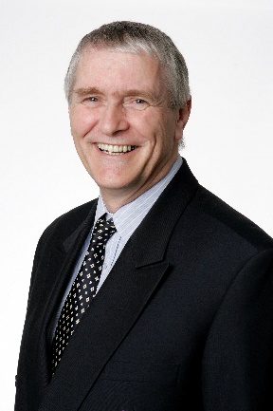

**Professor Best** is a Senior Lecturer at Middlesex University Business School. He is the Programme Leader for the M.Sc. Innovation Management and Entrepreneurship and the Project Leader of EDH@MDX, the enterprise development hub, which he set up to provide support to students and staff at Middlesex University.

**Professor Best described the lectures he will provide at FOS in the following manner:** These workshops are designed to stimulate the participants thinking about what it means to be enterprising, entrepreneurial and innovative. The workshops are a mixture of discussions and activities that will engage the participants in both practical application and deeper understanding of enterprise, entrepreneurship and innovation. In particular, it will show that the ability to be enterprising, entrepreneurial and innovative is necessary for the future, regardless of what employment the participant undertakes.

The content covers:  
  
•            Discuss what it means to be enterprising, entrepreneurial and innovative  
•            Looked at the future you face in relation to work and artificial intelligence.  
•            Defined Enterprise, Entrepreneurship and Innovation  
•            Look at mental modelling and how this limits our ability to do things  
•            Discuss some misconceptions about Enterprise, Entrepreneurship and Innovation  
•            Consider how to develop an enterprising, entrepreneurial and innovating mindset  
•            Test your ability to be enterprising, entrepreneurial and innovating

**Session 1** will be taught on **Friday, May 24, 18:00-19:30**, classroom C001.

**Session 2** will be taught on **Saturday, May 25, 10:40-12:10**, classroom 201.

We **kindly invite you all to attend the lecture**.